# [https://avatars2.githubusercontent.com/u/4156894?v=3&s=100](http://www.calstatela.edu/centers/hipic) CIS5200 Term Project Tutorial

#### Authors: Bajineni Ashok Archana Kumari, Choksi Mrudul Gaurang, Edulakanti Srinivas, Elahi Adnan

#### Instructor: [Jongwook Woo](https://www.linkedin.com/in/jongwook-woo-7081a85)

#### Date: 05/15/2020

**Lab Tutorial**

Bajineni Ashok Archana Kumari( [abajine@calstatela.edu](mailto:abajine@calstatela.edu))

Choksi, Mrudul Gaurang( [mchoksi@calstatela.edu](mailto:mchoksi@calstatela.edu) )

Edulakanti Srinivas ( [sedulak@calstatela.edu](mailto:sedulak@calstatela.edu) )

Elahi, Adnan( [aelahi@calstatela.edu](mailto:aelahi@calstatela.edu) )

05/15/2020

# Trained NFL data - ready for analysis

**Objectives**

**List what your objectives are:**

In this hands-on lab, you will learn how to:

* Downloaded data from Kaggle.com
* Uploaded data into HDFS using SCP command
* Create Tables in HDFS using Hive
* HiveQL commands to perform the analysis.
* Tableau for Visualization

**Platform Spec:**

**Cluster version**: Hadoop 2.7.1.2.4.2.0-258

**Cluster size**: 1003.6 GB

**Cluster Number of Nodes**: 3 (1 Master Node 2 Slave Nodes)

**Number of Processors**: 32

**Memory**: 241.821 GB

**CPU Model Name**: Intel(R) Xeon(R) CPU E5-2699C v4 @ 2.20GHz

**CPU Speed**: 2.20GHz

**Hive version**: Apache Hive version 1.2.1000.2.4.2.0-258

**Step 1: Downloaded Data and uploaded into HDFS**

**Explain what this step is for.** This step is to get data manually….

1. Downloaded data from Kaggle.com, below is the link

<https://www.kaggle.com/zinovadr/trained-nfl-data-ready-for-analysis/data>

There are three position type datasets named as Line backers, Defensive backers and wide receivers. We need to download them.

**Note:** The size of the files is huge you need to download on the system which is fast secure and reliable, and the download speed depends on the speed of the internet you are using.

1. We need to upload the dataset from our local PC to HDFS using the SCP command

Below is the SCP command to uploaded file into Hadoop Cluster

🡪 The path after SCP is your file path of your pc where file is currently located. EXAMPLE: Our files are located on desktop and in 5200_project folder.

* For username instead of abajine you need to give your username.
* Also, need to change IP address if you have different one.

$ scp /Users/archana/Desktop/Project-5200/predDB.csv [abajine@129.150.71.75:/home/abajine](mailto:abajine@129.150.71.75:/home/abajine)

$ scp /Users/archana/Desktop/Project-5200/predLB.csv [abajine@129.150.71.75:/home/abajine](mailto:abajine@129.150.71.75:/home/abajine)

$ scp /Users/archana/Desktop/Project5200/predDBInv.csv [abajine@129.150.71.75:/home/abajine](mailto:abajine@129.150.71.75:/home/abajine)

$ scp /Users/archana/Desktop/Project-5200/predLBInv.csv [abajine@129.150.71.75:/home/abajine](mailto:abajine@129.150.71.75:/home/abajine)

$ scp /Users/archana/Desktop/Project-5200/predWRInv.csv [abajine@129.150.71.75:/home/abajine](mailto:abajine@129.150.71.75:/home/abajine)

$ scp /Users/archana/Desktop/Project-5200/predWR.csv [abajine@129.150.71.75:/home/abajine](mailto:abajine@129.150.71.75:/home/abajine)

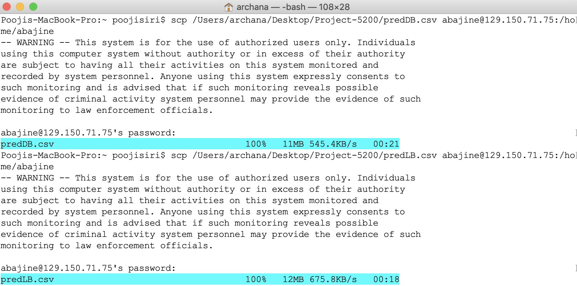

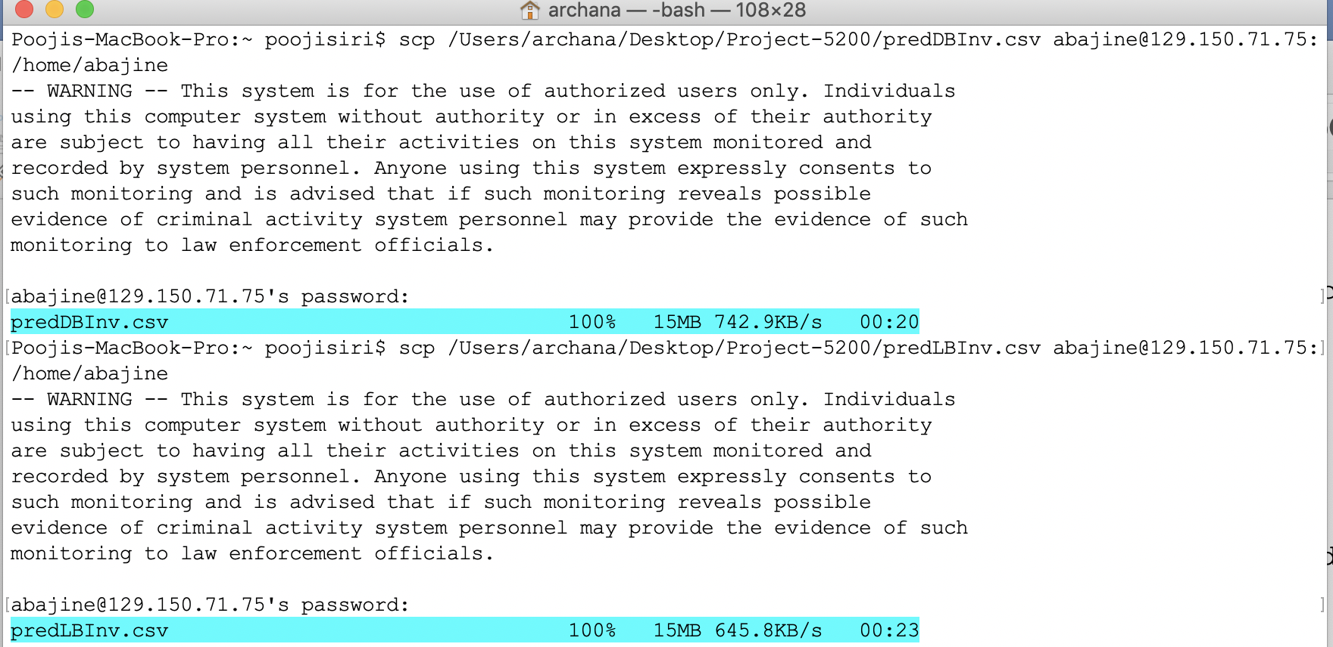

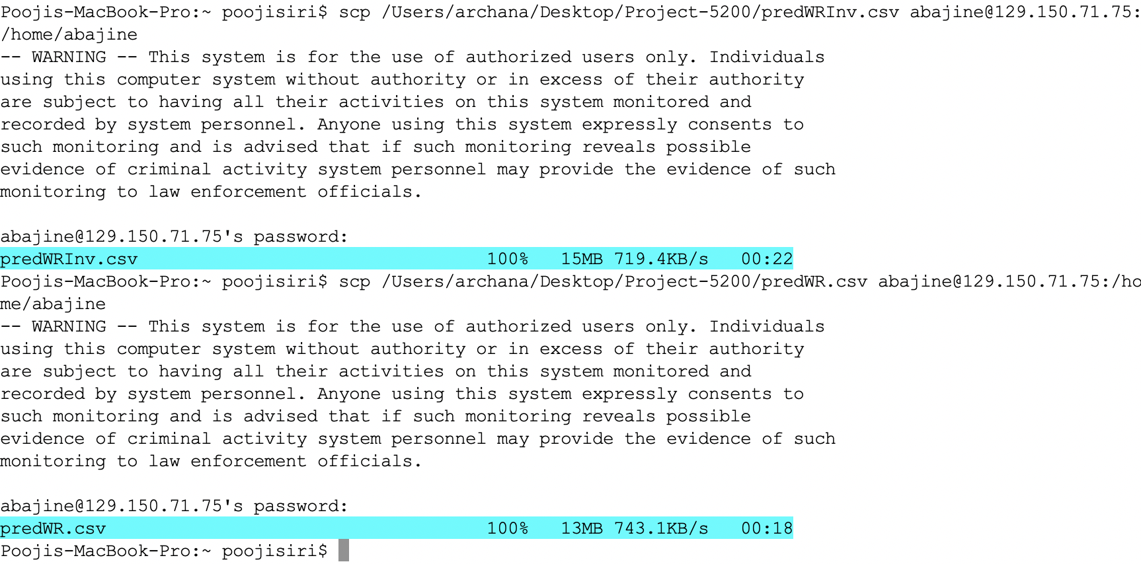

1. We need to remotely access our Oracle BCDE Cluster. Using putty or terminal (in windows, Linux or MAC), using the following command

|  |
| --- |
| $ ssh abajine@129.150.71.75 |

Do not forgot to change the username and if you have different IP address.

Below screen shot show us that we have successfully connected to Oracle BCDE Cluster

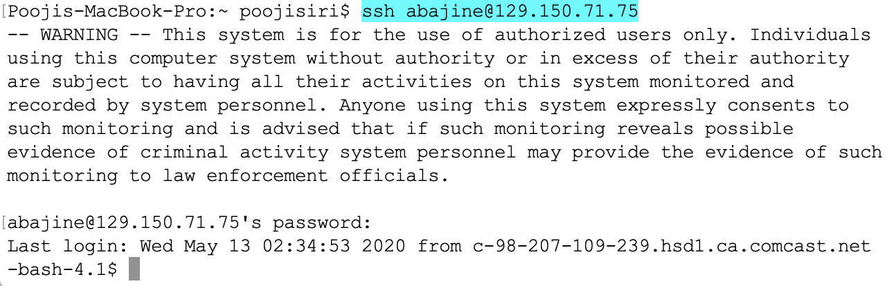

1. The below two commands show us that the files are uploaded to HDFS:

|  |
| --- |
| -bash-4.1$ ls |



|  |
| --- |
| -bash-4.1$ ls -al |

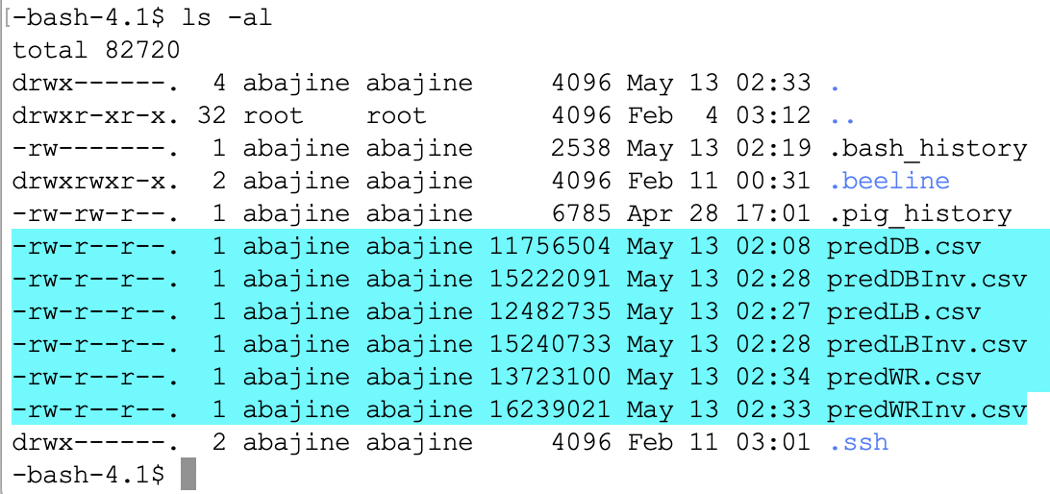

1. Once the files are uploaded to HDFS we have created a directory NFLdata to move predDB file for analysis.

|  |
| --- |
| $ hdfs dfs -mkdir NFLdata  -bash-4.1$ hdfs dfs -ls |

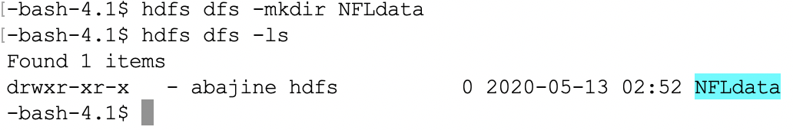

1. We have check whether the directory is created under our username. The below command is used for confirmation

|  |
| --- |
| bash-4.1$ hdfs dfs -ls /user/abajine |

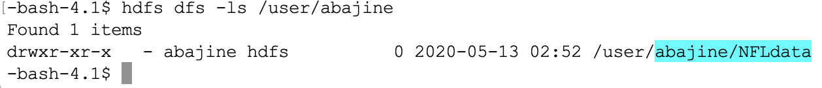

1. Now Upload predDB.csv file to NFLdata directory using the following command:

To check whether the file is upload to directory or not, use the following command:

|  |
| --- |
| -bash-4.1$ hdfs dfs -put predDB.csv NFLdata bash-4.1$ hdfs dfs -ls NFLdata |

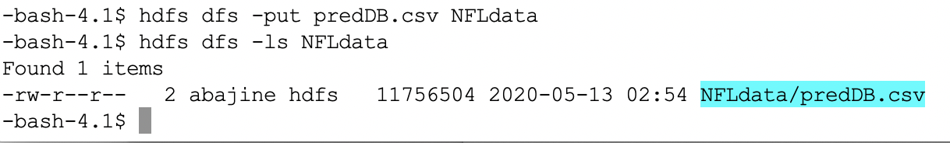

9) The below HDFS command will make the beeline work without any issue

|  |
| --- |
| $ hdfs dfs -chmod -R o+w NFLdata |

**Step 2: Created External Tables for Analysis:**

1) Open the beeline interface using the following command to run the Hive Queries.

|  |
| --- |
| -bash-4.1$ beeline |

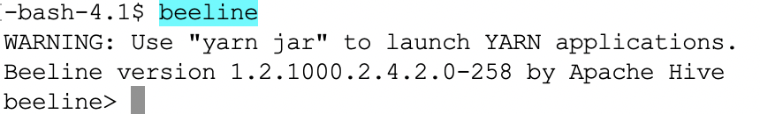

2) Once cursor prompts as beeline you need to enter the following command which is mentioned below to connect to Hive.

Do not forgot to change the database name to your database name

|  |
| --- |
| !connectjdbc:hive2://bigdai1-bdcsce-1:2181,bigdai1-bdcsce-2:2181,bigdai1-bdcsce 3:2181/;serviceDiscoveryMode=zooKeeper;zooKeeperNamespace=hiveserver2?tez.queue.name=interactive bdcsce_admin |

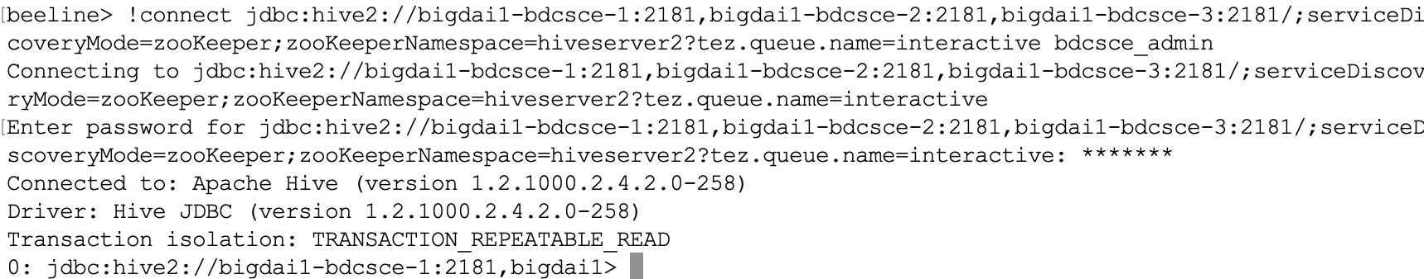

3) Once you are in Hive please see whether your Database already exists with your name. If it doesn’t show, please create one with your username.

|  |
| --- |
| jdbc:hive2://bigdai1-bdcsce-1:2181,bigdai1> show databases; |

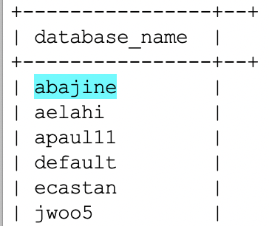

If there is no database on your name, create one using the following command:

|  |
| --- |
| CREATE database IF NOT EXISTS your_username; |

4) Now you need to use your database, which you created using the following command because it pulls up the tables created under your username

|  |
| --- |
| 0: jdbc:hive2://bigdai1-bdcsce-1:2181,bigdai1> use abajine; |

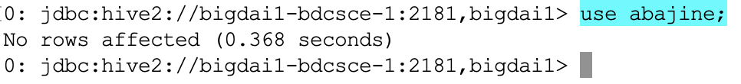

5) We need to create external table for analysis using the below command and define the variables whether it is string, float or integer etc.

Table1: The below HiveQL creates an external table in the beeline, use your name instead of abajine

|  |
| --- |
| CREATE EXTERNAL TABLE IF NOT EXISTS PredDB(Field_Type STRING, Play_Type STRING, Roster_Position STRING, Stadium_Type STRING, Temperature INT, Weather STRING, Time FLOAT, predict STRING) ROW FORMAT DELIMITED FIELDS TERMINATED BY ',' STORED AS TEXTFILE LOCATION '/user/abajine/NFLdata'  TBLPROPERTIES ('skip.header.line.count'='2'); |

To check whether the table is created or not use the below HiveQL:

|  |
| --- |
| jdbc:hive2://bigdai1-bdcsce-1:2181,bigdai1> show tables; |

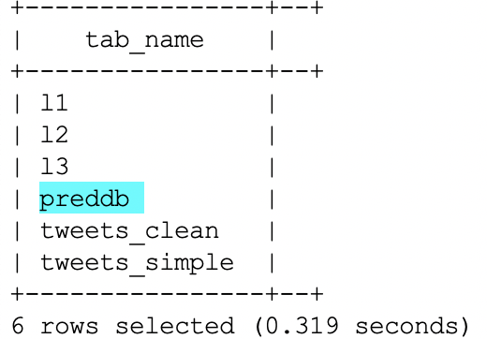

6) Once the external tables are created you need to see if you have assigned the data correctly with string, integer, float commands or not by using the below command.

Using the below command, we can describe the table created.

|  |
| --- |
| jdbc:hive2://bigdai1-bdcsce-1:2181,bigdai1> describe predDB; |

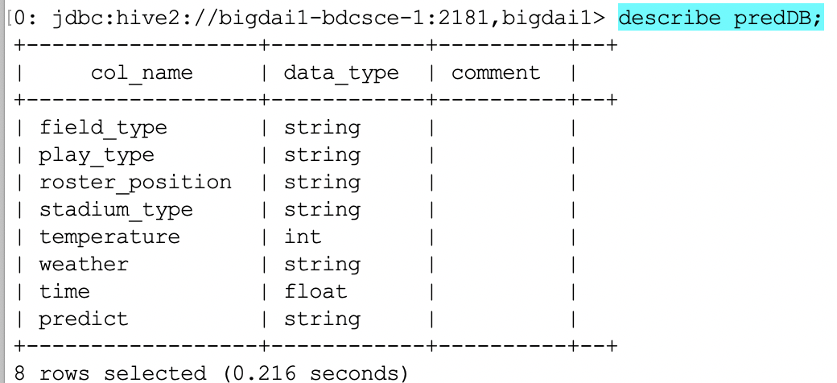

7) This step is very important to see whether the table has the values. if you don’t see the values you

need to Drop the tables and rerun the command from step 5.

The below command displays the content from the table.

|  |
| --- |
| > select * from predDB limit 5; |

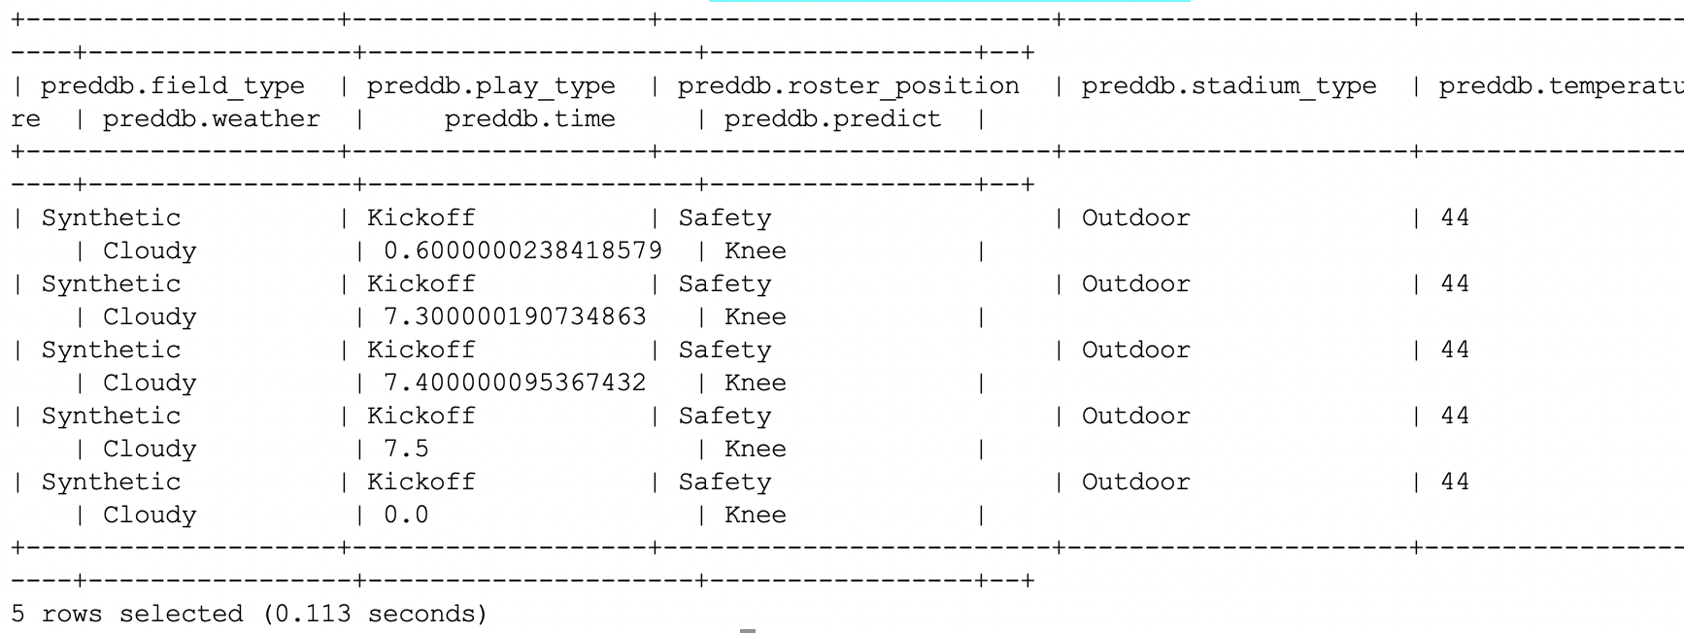

8) We wanted to Analyze the first thing in this project is to see total injury count in position

type.

We wanted to show the count of the predict column which has two attributes Ankle and Knee.

|  |
| --- |
| > Select predict,count (*) AS count FROM preddb group by predict order by count; |

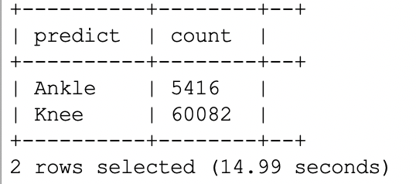

1. The idea behind using the below HiveQL query to analyze body part injuries on both the Turfs .

The below command displays the count from the field_type column.

|  |
| --- |
| > Select Field_Type ,count (*) AS count FROM preddb group by Field_Type order by count; |

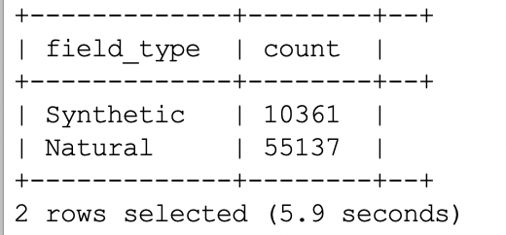

From the above result we analyze that the number of injuries on Natural turf are more than the synthetic turf.

1. The below command is used to do in-depth Analysis on type of ground, field type how many injuries have occurred in particular position type.

Using the below command, we wanted to show the count of three different columns from PredDB table.

|  |
| --- |
| > Select Field_Type,Stadium_Type,predict, count (*) AS count FROM preddb group by Field_Type,Stadium_Type,predict order by count; |

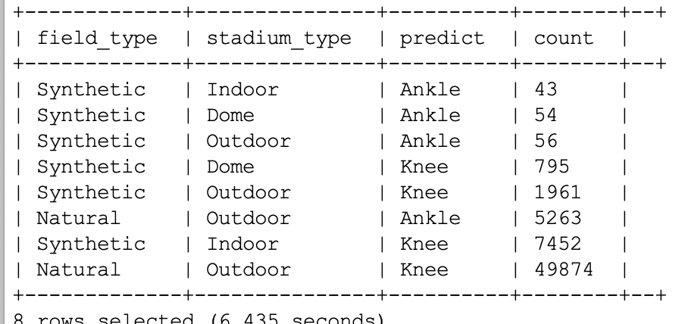

11) Now we are trying to use the below command to add csv filed to NFL directory.

The below command adds the predLB file to NFL directory

|  |
| --- |
| $ hdfs dfs -put predLB.csv NFLdata  $ hdfs dfs -ls NFLdata |

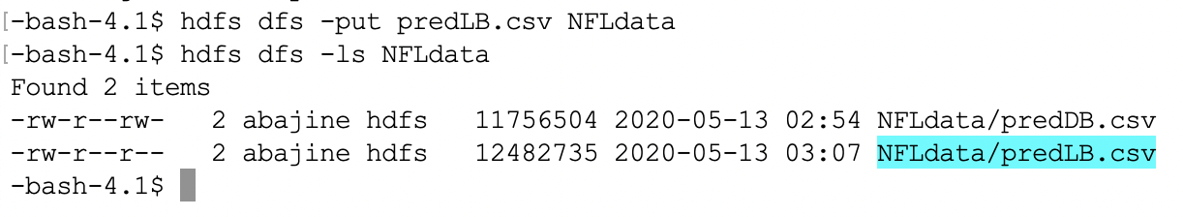

12) Repeat the steps for other position type

Created second external table predLB using the following command.

|  |
| --- |
| CREATE EXTERNAL TABLE IF NOT EXISTS PredLB(Field_Type STRING, Play_Type STRING, Roster_Position STRING, Stadium_Type STRING, Temperature INT, Weather STRING, Time FLOAT, predict STRING) ROW FORMAT DELIMITED FIELDS TERMINATED BY ',' STORED AS TEXTFILE LOCATION '/user/abajine/NFLdata' TBLPROPERTIES ('skip.header.line.count'='2'); |

13) Command is used to display the table

The below command will display the table created.

|  |
| --- |
| jdbc:hive2://bigdai1-bdcsce-1:2181,bigdai1> show tables; |

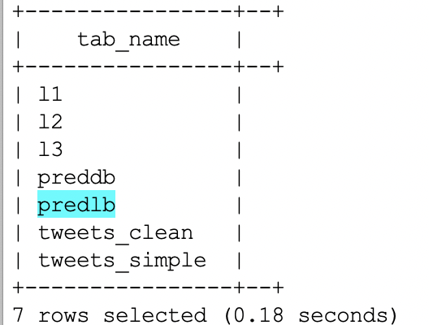

Using the below command, we can describe the table created

|  |
| --- |
| jdbc:hive2://bigdai1-bdcsce-1:2181,bigdai1> describe predLB; |

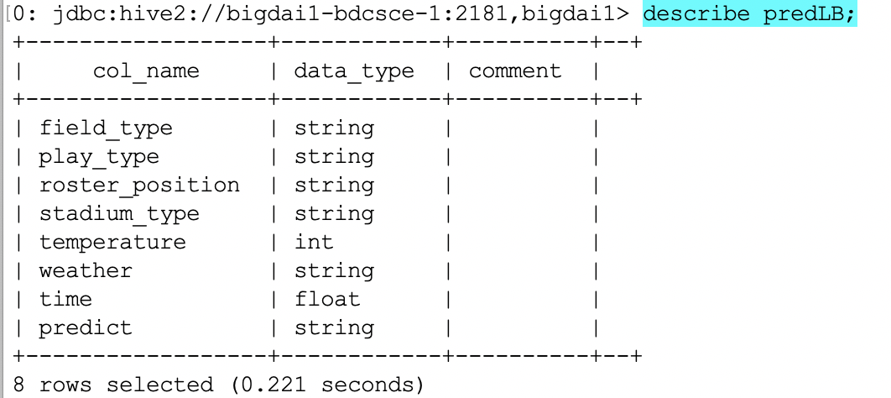

Using the below command, we can see the content from the table

|  |
| --- |
| jdbc:hive2://bigdai1-bdcsce-1:2181,bigdai1> select * from predLB limit 5; |

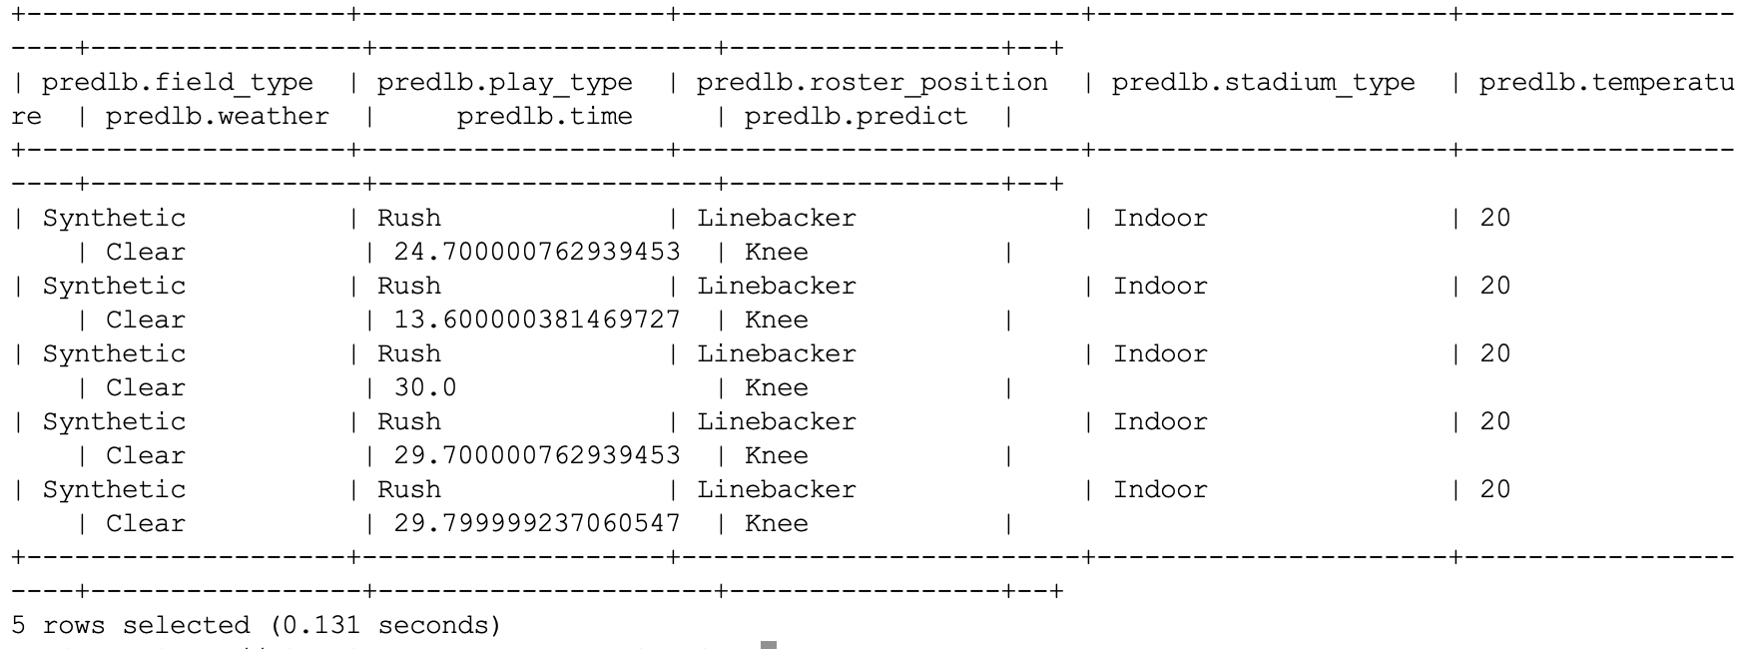

14) We wanted to show the count of the predict column which has two attributes Ankle and Knee from predLB table.

|  |
| --- |
| jdbc:hive2://bigdai1-bdcsce-1:2181,bigdai1> Select predict ,count (*) AS count FROM predlb group by predict order by count; |

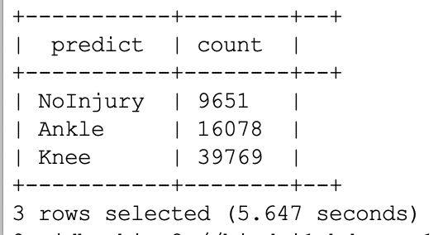

15) Using the below Query, we wanted to show the count of field_type column from predLB table.

|  |
| --- |
| jdbc:hive2://bigdai1-bdcsce-1:2181,bigdai1> Select Field_Type ,count (*) AS count FROM predlb group by Field_Type order by count; |

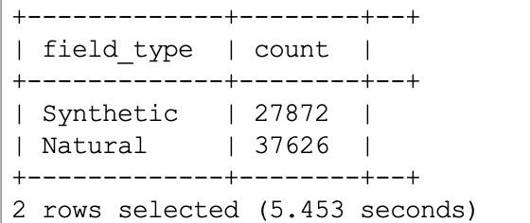

16) We wanted to analyze to see how many injuries have happened during the playtype in both the turfs

Using the below HiveQL we wanted to show the count of two columns field_type, play_type and predict from the predLB table.

|  |
| --- |
| > Select Field_Type, Play_Type, predict, count (*) AS count FROM predlb group by Field_Type, Play_Type, predict order by count; |

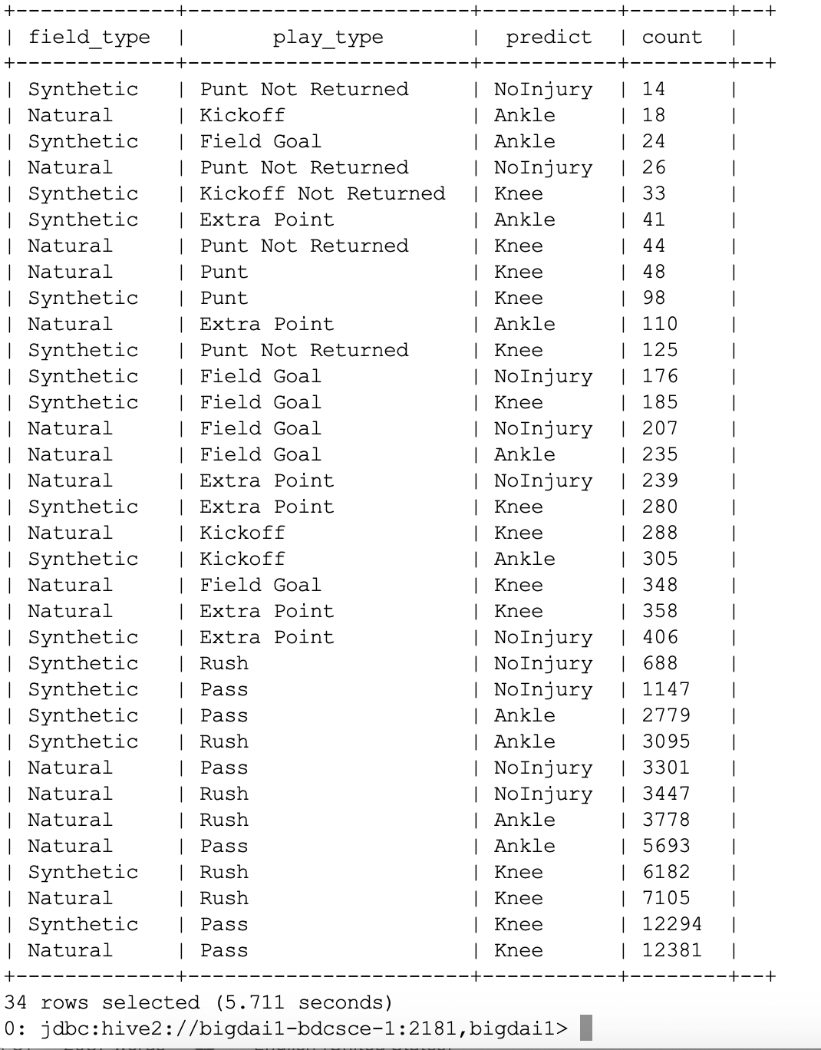

17) The below HDFS Command adds the third file predWR.csv to our NFLdata directory.

|  |
| --- |
| $ hdfs dfs -put predWR.csv NFLdata  $ hdfs dfs -ls NFLdata |

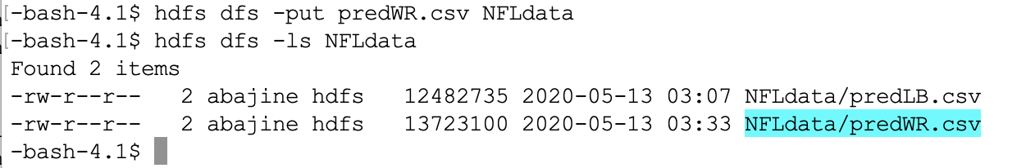

18) Created third table predWR using the below HiveQL

|  |
| --- |
| CREATE EXTERNAL TABLE IF NOT EXISTS PredWR(Field_Type STRING, Play_Type STRING, Roster_Position STRING, Stadium_Type STRING, Temperature INT, Weather STRING, Time FLOAT, predict STRING)ROW FORMAT DELIMITED FIELDS TERMINATED BY ',' STORED AS TEXTFILE LOCATION'/user/abajine/NFLdata' TBLPROPERTIES ('skip.header.line.count'='2'); |

19) The below HiveQL displays the table created predWR.

|  |
| --- |
| jdbc:hive2://bigdai1-bdcsce-1:2181,bigdai1> show tables; |

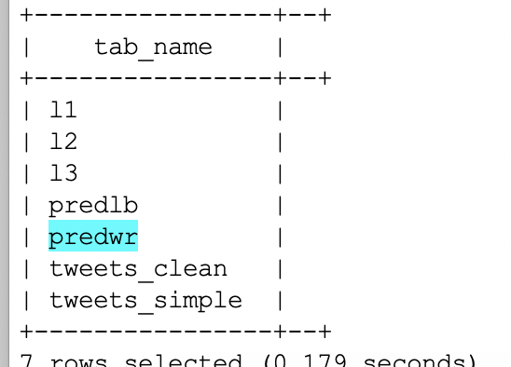

Using the below command, we can describe the table created

|  |
| --- |
| jdbc:hive2://bigdai1-bdcsce-1:2181,bigdai1>describe predWR; |

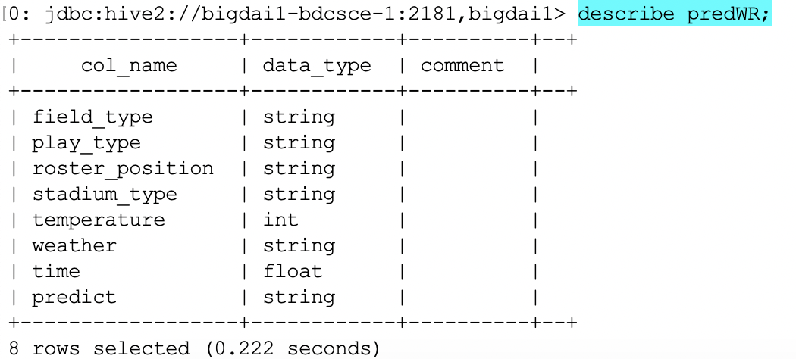

The below HiveQL displays the content from the table predWR table

|  |
| --- |
| jdbc:hive2://bigdai1-bdcsce-1:2181,bigdai1>select * from predWR limit 5; |

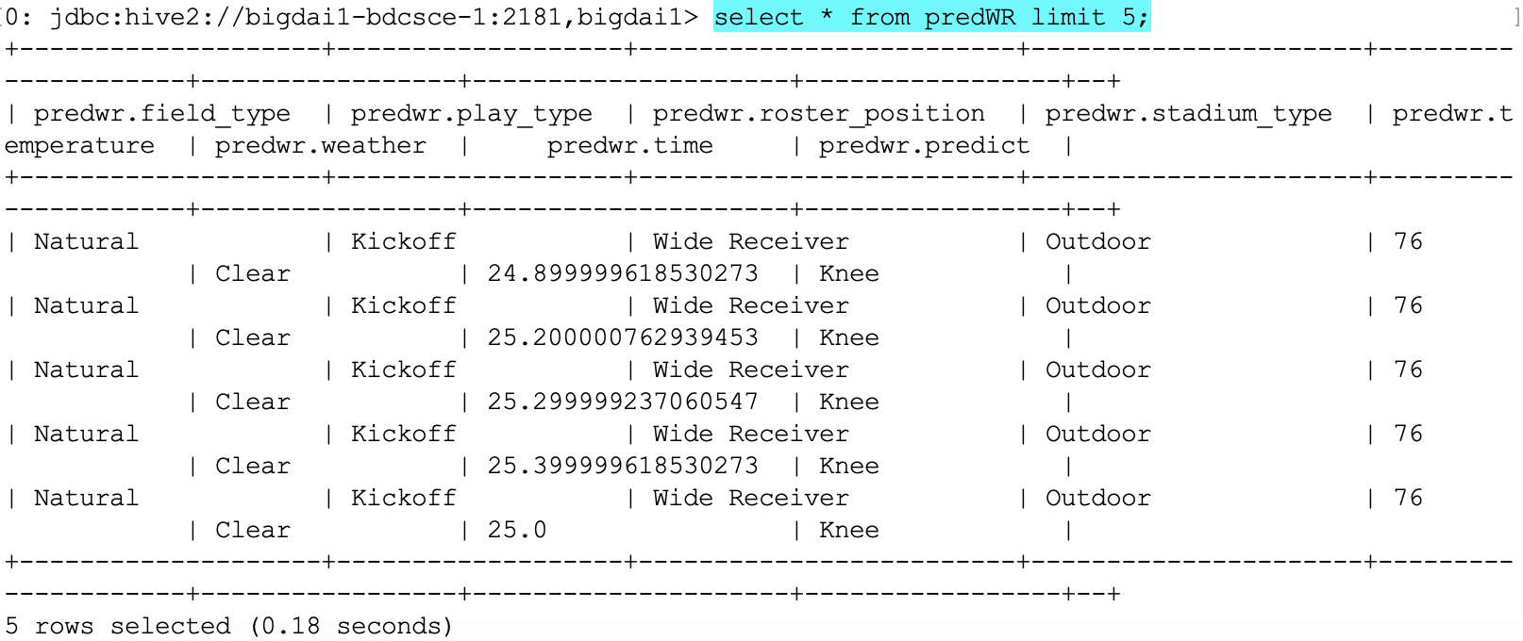

From the below HiveQL we wanted to show the count of stadium_type from the predWR table.

|  |
| --- |
| jdbc:hive2://bigdai1-bdcsce-1:2181,bigdai1>Select Stadium_Type ,count (*) AS count FROM predwr group by Stadium_Type order by count; |

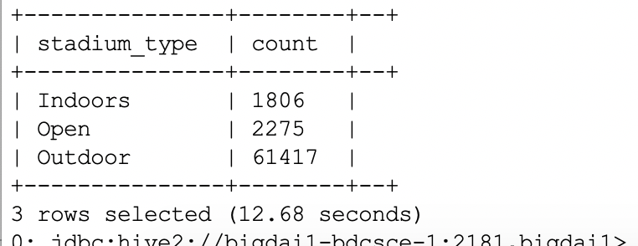

Below HiveQL will display the count of field_type from the predWR table

|  |
| --- |
| jdbc:hive2://bigdai1-bdcsce-1:2181,bigdai1> Select Field_Type ,count (*) AS count FROM predwr group by Field_Type order by count; |

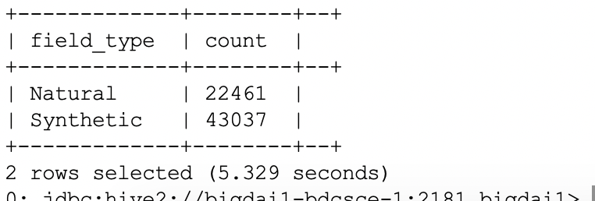

The below HiveQL will display the count from the predWR table of columns field_type, play_type and

stadium_type.

|  |
| --- |
| jdbc:hive2://bigdai1-bdcsce-1:2181,bigdai1> Select Field_Type,Play_Type,Stadium_Type, count (*) AS count FROM predwr group by Field_Type,Play_Type,Stadium_Type order by count; |

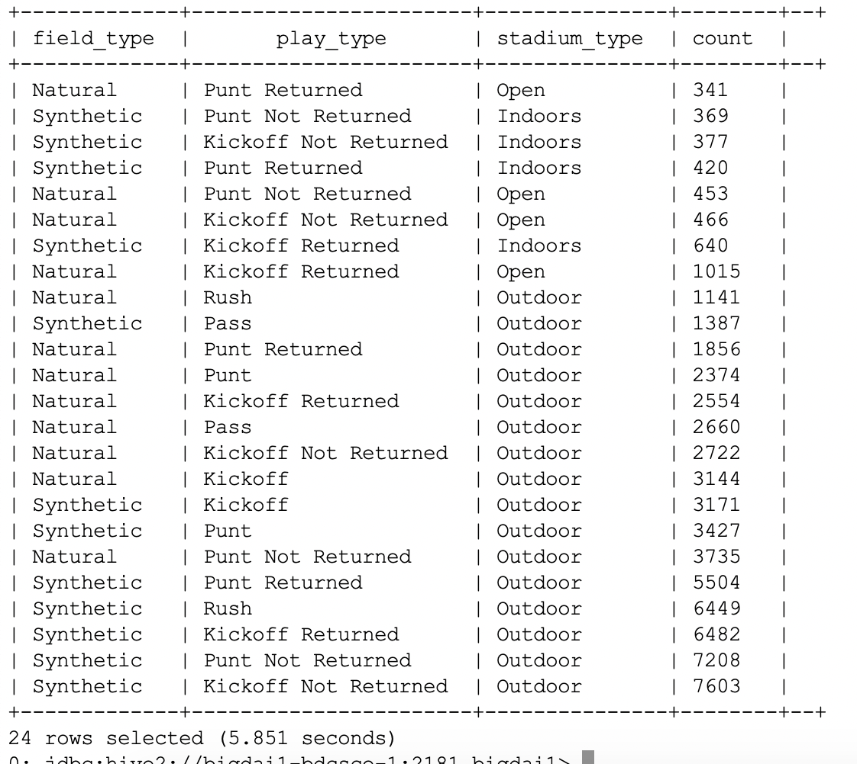

20) The below HDFS command will display the all the files uploaded into NFLdata directory

|  |
| --- |
| -bash-4.2$ hdfs dfs -ls NFLdata |

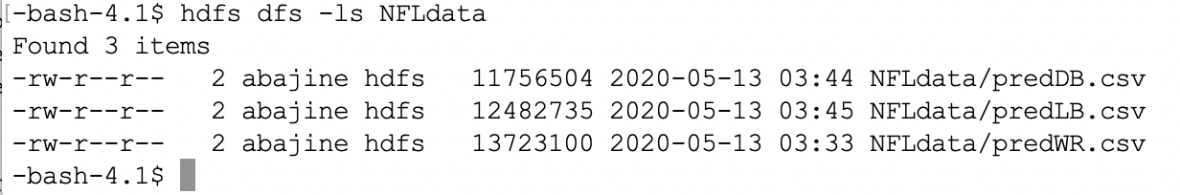

The below HiveQL will display all the tables we created.

|  |
| --- |
| jdbc:hive2://bigdai1-bdcsce-1:2181,bigdai1> show tables; |

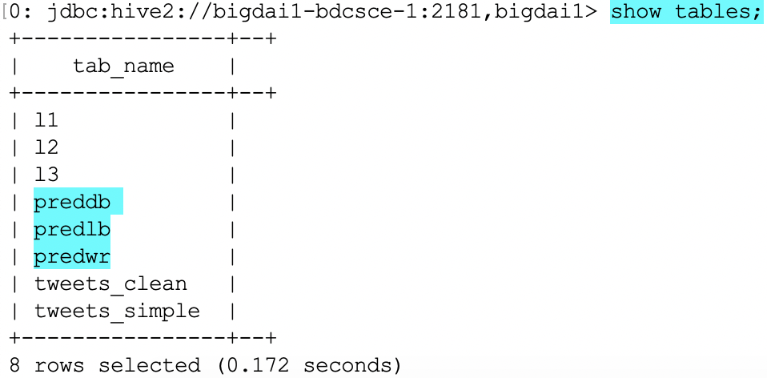

21) Using the below HDFS Commands we will be downloading data

|  |
| --- |
| -bash-4.1$ hdfs dfs -get /user/abajine/NFLdata/predDB.csv log_result.out  -bash-4.2$ cat log_result.out |

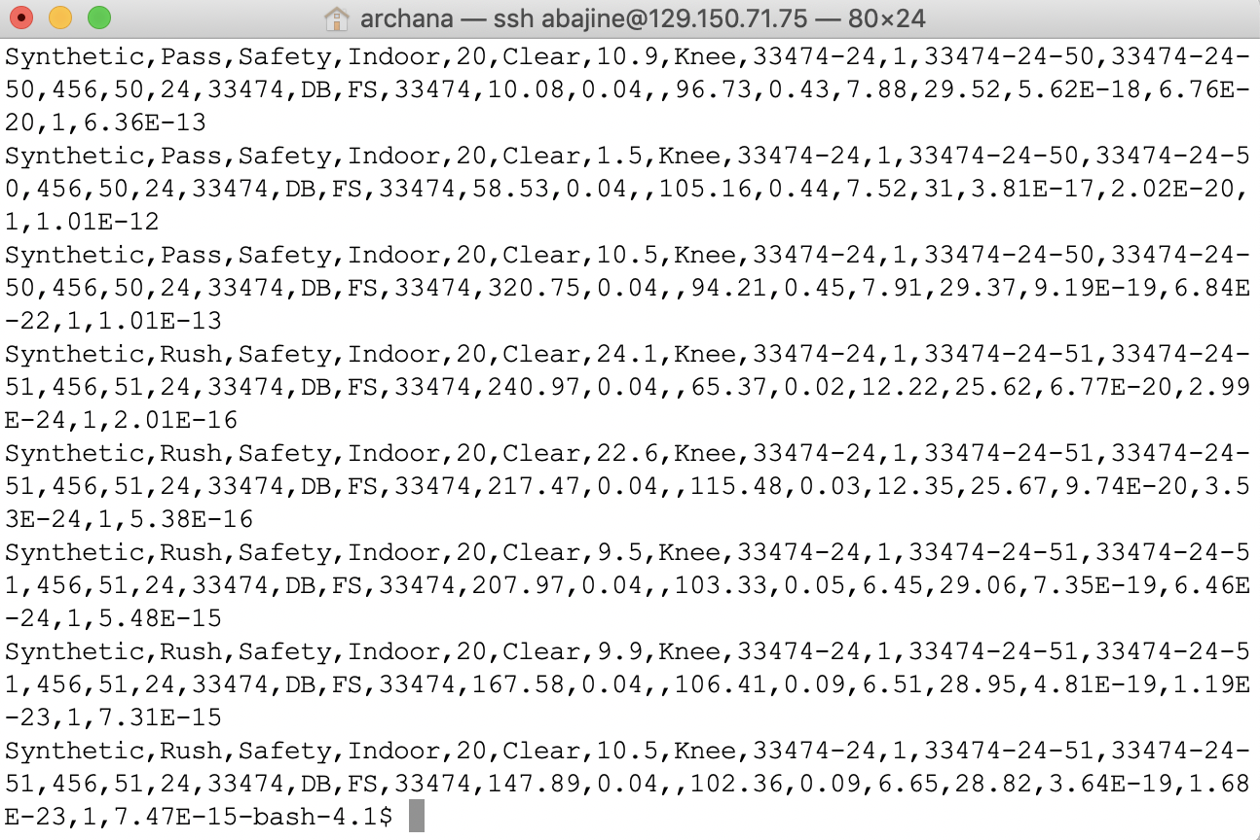

22) Now take the new gitbash to run the below commands.

|  |
| --- |
| $ scp [abajine@129.150.71.75:/home/abajine/log_result.out](mailto:abajine@129.150.71.75:/home/abajine/log_result.out) . |

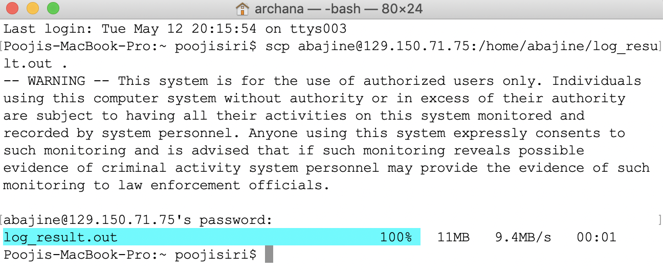

|  |
| --- |
| $ ls |

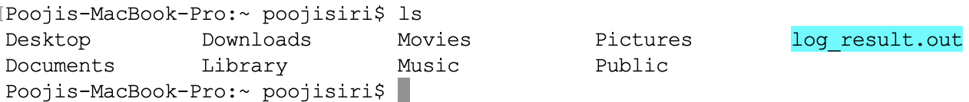

|  |
| --- |
| $ hdfs dfs -get /user/abajine/NFLdata/predLB.csv log1_result.out  -bash-4.2$ cat log1_result.out |

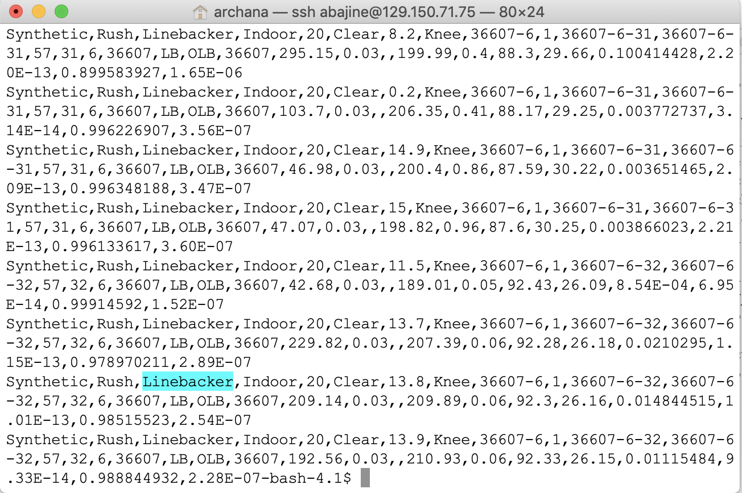

|  |
| --- |
| $ scp [abajine@129.150.71.75:/home/abajine/log1_result.out](mailto:abajine@129.150.71.75:/home/abajine/log1_result.out) . |

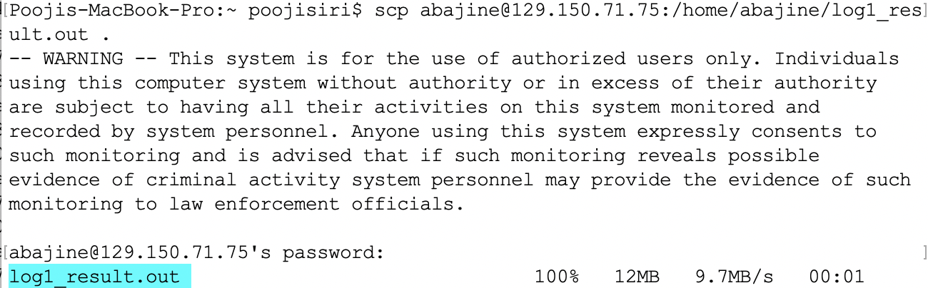

|  |
| --- |
| $ ls |

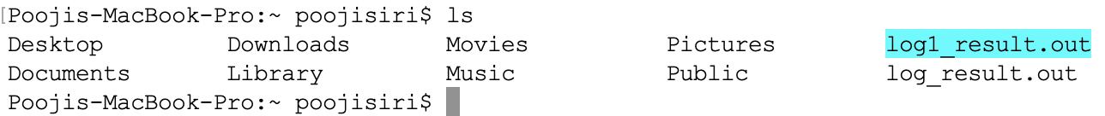

|  |
| --- |
| bash-4.2$ hdfs dfs -get /user/abajine/NFLdata/predWR.csv log2_result.out  -bash-4.2$ cat log2_result.out |

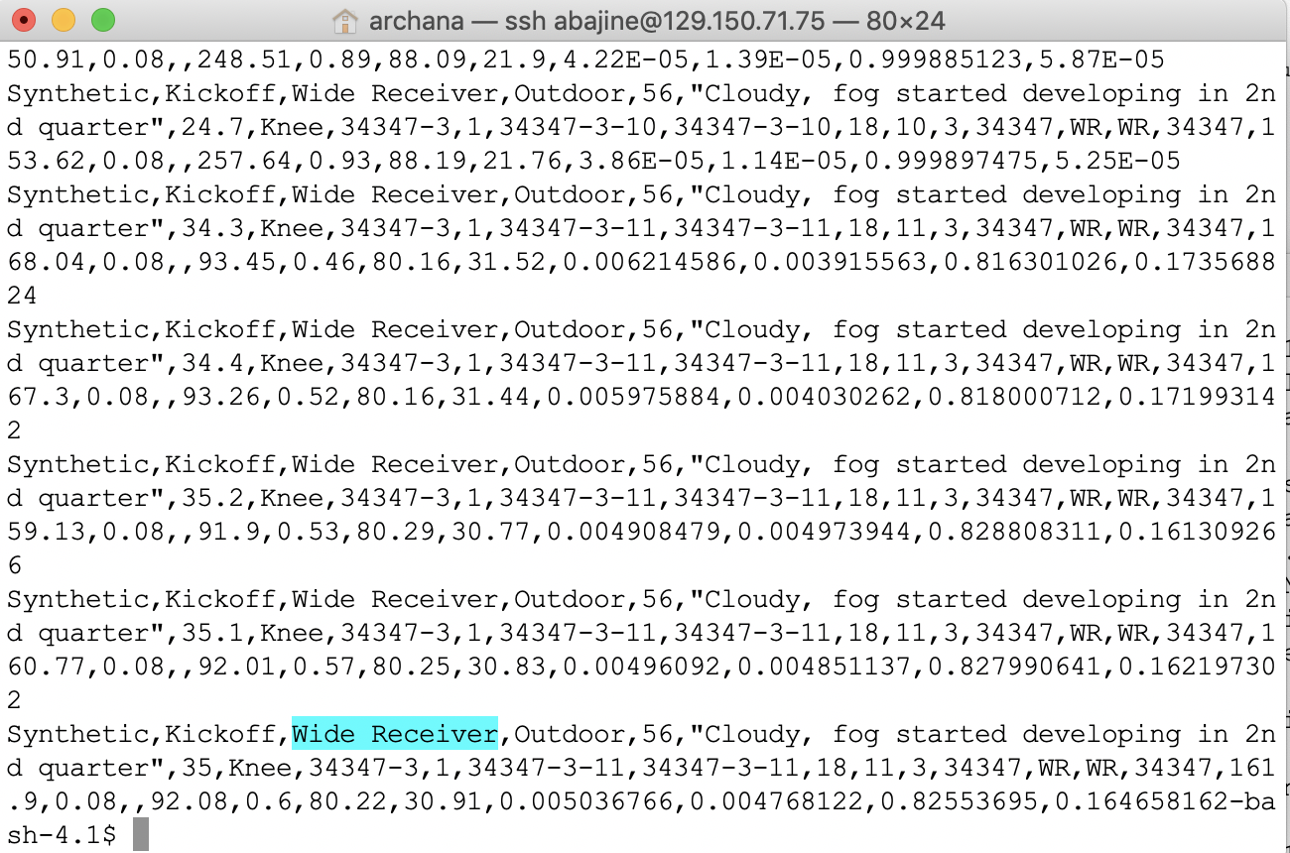

|  |
| --- |
| $ scp abajine@129.150.71.75:/home/abajine/log2_result.out . |

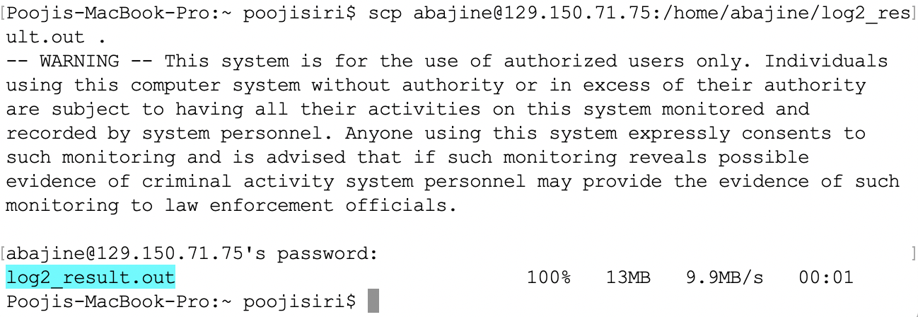

Now the file has been successfully downloaded from HDFS and it is ready to use it for visualization.

|  |
| --- |
| $ ls |

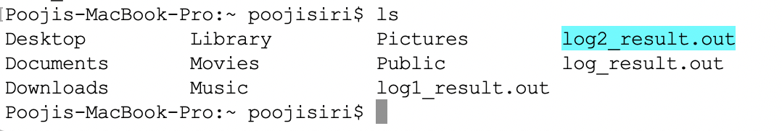

The below screen shot shows that the output files saved on desktop:

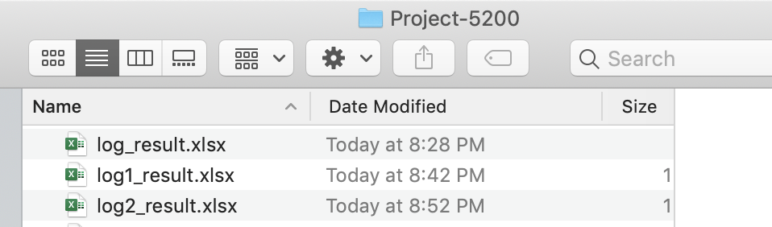

**Step 3: Visualization**

Download the tableau and export the files to analyze the data visually in terms of graphs

* In the below visualization we have analyzed the NFL data to find out two important attributes.
* One being the field type and the other being the injuries caused in defensive back position type
* We could see the number of injuries on natural type are more when compare to Synthetic type.
* Injuries to knee are more than injuries to Ankle on Natural field.



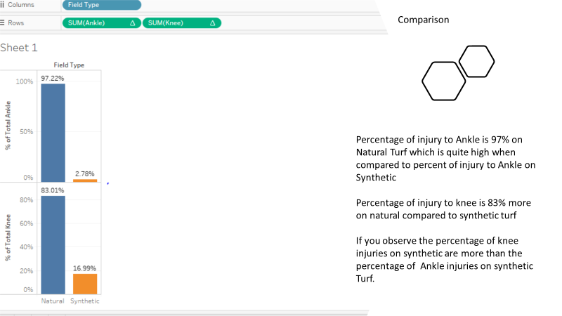

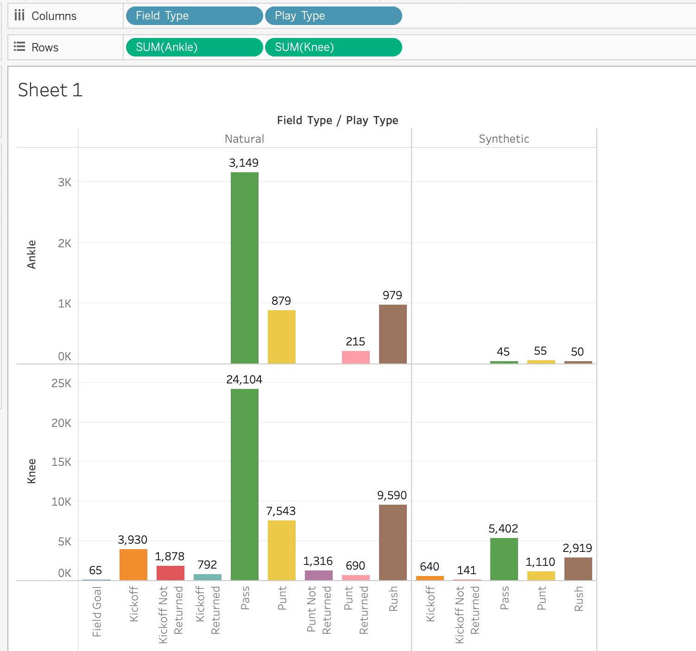

* In the above table we have taken field type, play type and the injury to knee and ankle figures to analyze the number of injuries in particular play type on natural and synthetic ground.
* From the above table we can clearly see that injuries to players have caused by play type “pass” are more on natural turf.
* While on synthetic turf the number of injuries to knee are more while pass playtype
* Injuries to body part Ankle are more on synthetic turf while play type is Punt



* The above visualization has fieldtype ,weather and the number of injury fields.
* Reason for using these attributes is to analyze the max temperature and min temperatures and the type of weather results in more number of injuries on both Turfs.

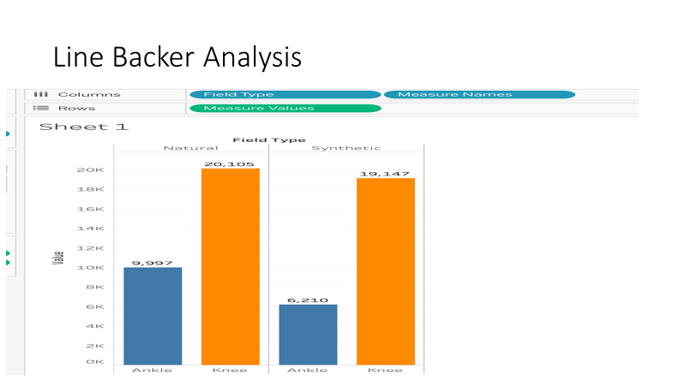

* We have analysis for the linebackers on both field types
* On the overall we could see the number of injuries on the natural field type are more as usual.
* Two important things we analyzed from the above visualization is there is not much gap between injury figures in both field types.
* The other being when you compare the figures between the defensive and line backer you will see injuries for line back position are more.

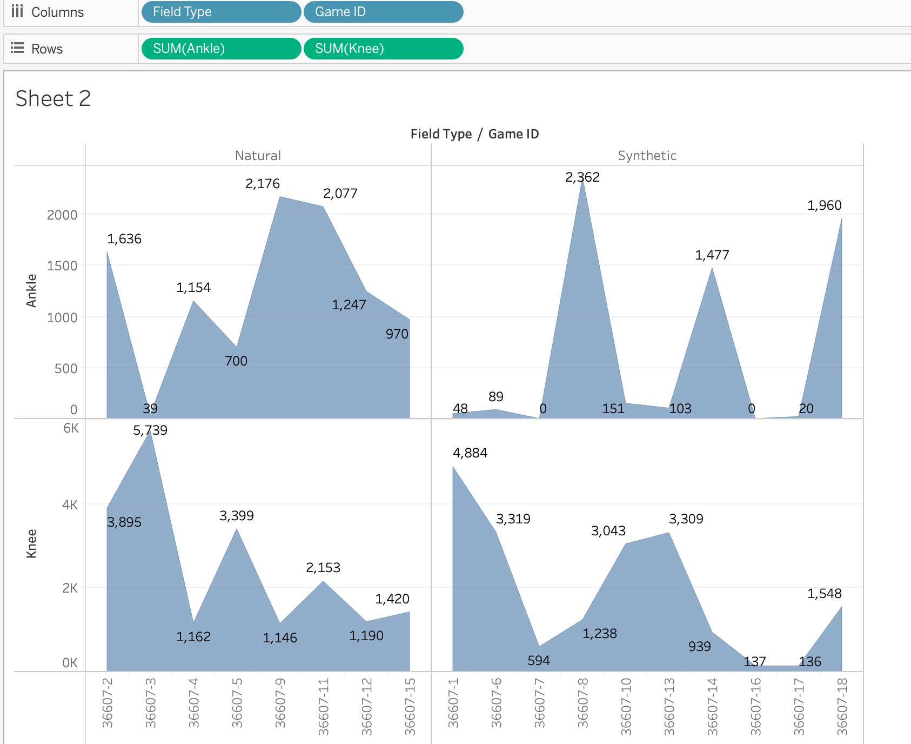

* The above visualization was performed to analyze the injuries as per Game Id connected to Field_Type
* Three types of variables are used to arrive at the decision Game Id, predict Column and Field Type
* In Natural Turf, the highest number of injuries to Ankle (2176) and Game ID: 36607-9 and In Synthetic Turf the highest number of Injuries to Ankle ( 2362) and GameID: 36607-8
* In Natural Turf, the highest number of injuries to Knee (5739) and GameID: 36607-3 and In Synthetic Turf the highest number of Injuries to Knee (4884) and GameID: 36607-1

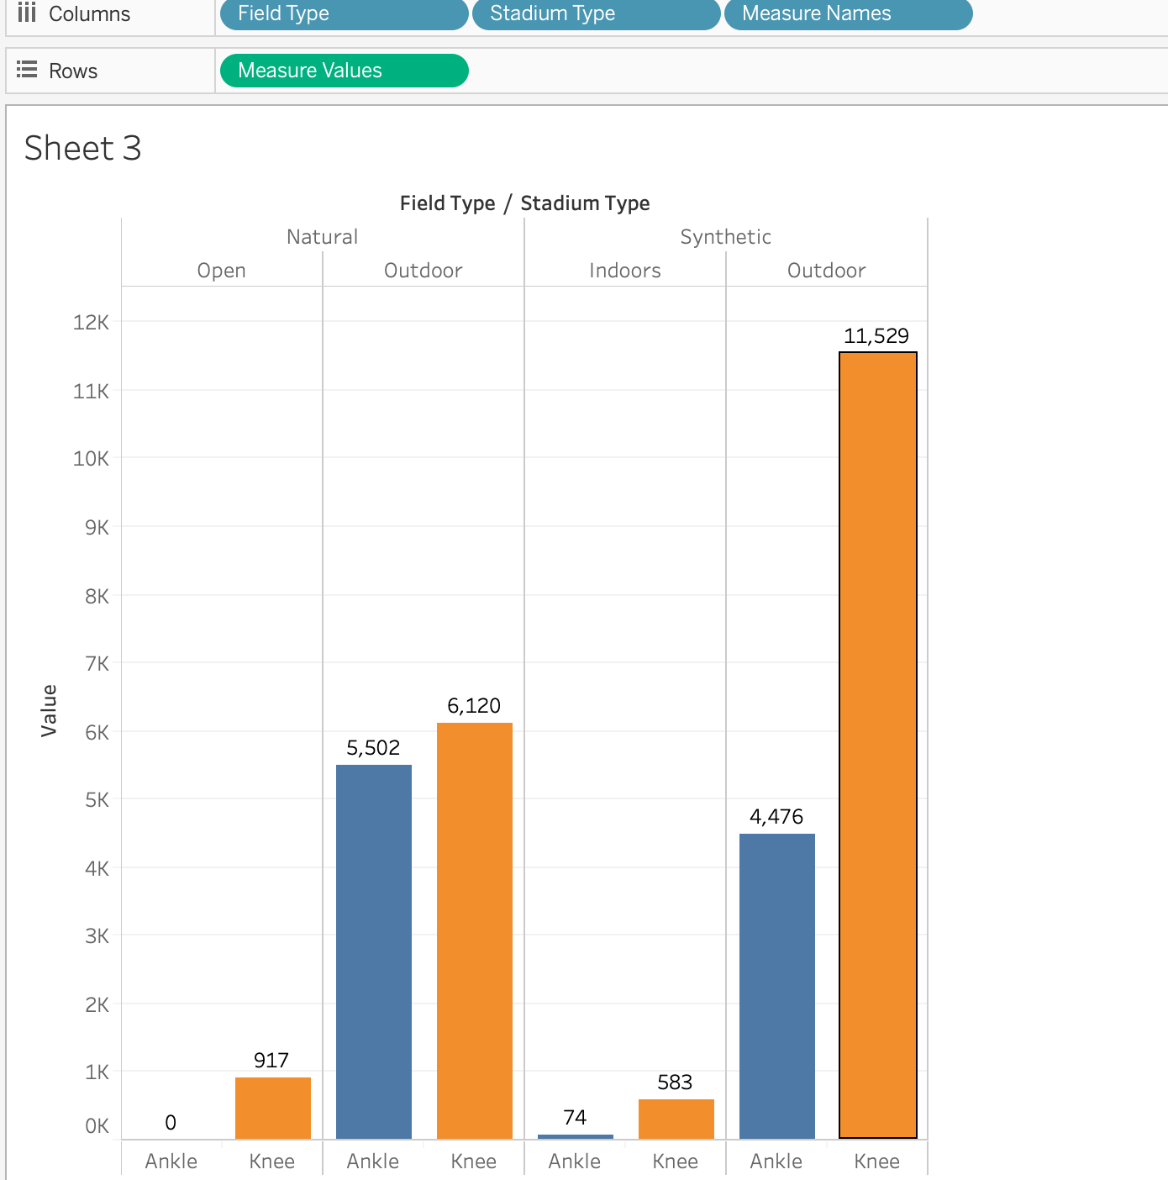

* We have used field type ,stadium type and the amount of injuries to identify the number of injuries in indoors and outdoors.
* The number of knee injuries on synthetic floor in outside stadium are more when compared to natural field type.
* Knee injuries are higher in all three types of positions types.

**Summary:**

This project was taken to analyze to see the number of injuries in particular type of position, field type , stadium type because we wanted to identify most least preferred ground types .The reason being the investors and sponsors would spend so much of money on players well being and the profit would be maximized only when the important players play matches without missing. We came to conclusion to advise investors , stakeholders, sponsors, players and fans is playing on synthetic field will result in less number of injuries.We have downloaded the dataset and used in HDFS to analyze using hadoop and visualization of the results was in Tableau.

**References:**

1. <https://www.kaggle.com/zinovadr/trained-nfl-data-ready-for-analysis>
2. <https://en.wikipedia.org/wiki/National_Football_League>
3. <https://github.com/esrinivas08/NFL-Data-Analysis>